# 1507_esb_logo_1_1.eps

# ESB Newsletter November 25, 2022

# Reminder: Call for nominations for 2023 ESB Scientific Awards | Education Awards 2023 | 2023 Biomaterials Science Lectureship Award

Dear members of the European Society for Biomaterials,

We would like to remind you that the call for nominations for the 2023 ESB Scientific Awards is now open. Please do not miss the opportunity to nominate a colleague for one of our four prestigious awards:

**George Winter Award**: established to recognize, encourage, and stimulate outstanding research contributions to the field of biomaterials. The nominee must have contributed significantly to the knowledge in the field of biomaterials through basic, experimental and/or clinical research.

**Jean Leray Award**: established to recognize, encourage, and stimulate outstanding research contributions to the field of biomaterials by early-career scientists. The nominee, not older than 40 years of age and with no more than eight years of post-doctoral experience at the close of nomination (please visit the website for more details on the eligibility criteria), must have contributed significantly to the knowledge in the field of biomaterials through basic, experimental and/or clinical research.

**International Award**: established as a recognition of scientists who have generally spent their career outside Europe, who have been internationally recognized, have a high scientific profile, and have made major contributions to the field of biomaterials. Strong evidence of collaborations with members of our scientific community in Europe throughout their career is expected.

**Klaas de Groot Award**: established as a prestigious recognition of scientists who have shown a distinct ability to provide excellent mentorship and guidance to young researchers, helping them to establish their own independent career. We look for colleagues who have nurtured young talent, and who have selflessly invested in this talent, creating a next generation biomaterials scientists in Europe.

For further information about the awards and the process of nomination, please visit Awards webpage on the European Society for Biomaterials website. Please note that re-nomination of a candidate from previous years is possible. The deadline for nominations is **November 30, 2022**.

In addition to these scientific achievement awards, applications for the **Julia Polak European Doctoral Awards** and the **Racquel LeGeros Award** are also welcome. For more information please visit our website and go to the Education webpage.

Finally, The call for nominations for the **2023 Biomaterials Science Lectureship Award**, the official journal of the ESB is currently open. More information can be found on the Biomaterials Science [blog](https://blogs.rsc.org/bm/2022/10/03/biomaterials-science-lectureship-2023-nominations-now-open/?doing_wp_cron=1665398683.0566430091857910156250) and [Twitter](https://twitter.com/BioMaterSci/status/1576894112904740864). The deadline for the nominations is December 31, 2022.

Kind regards,

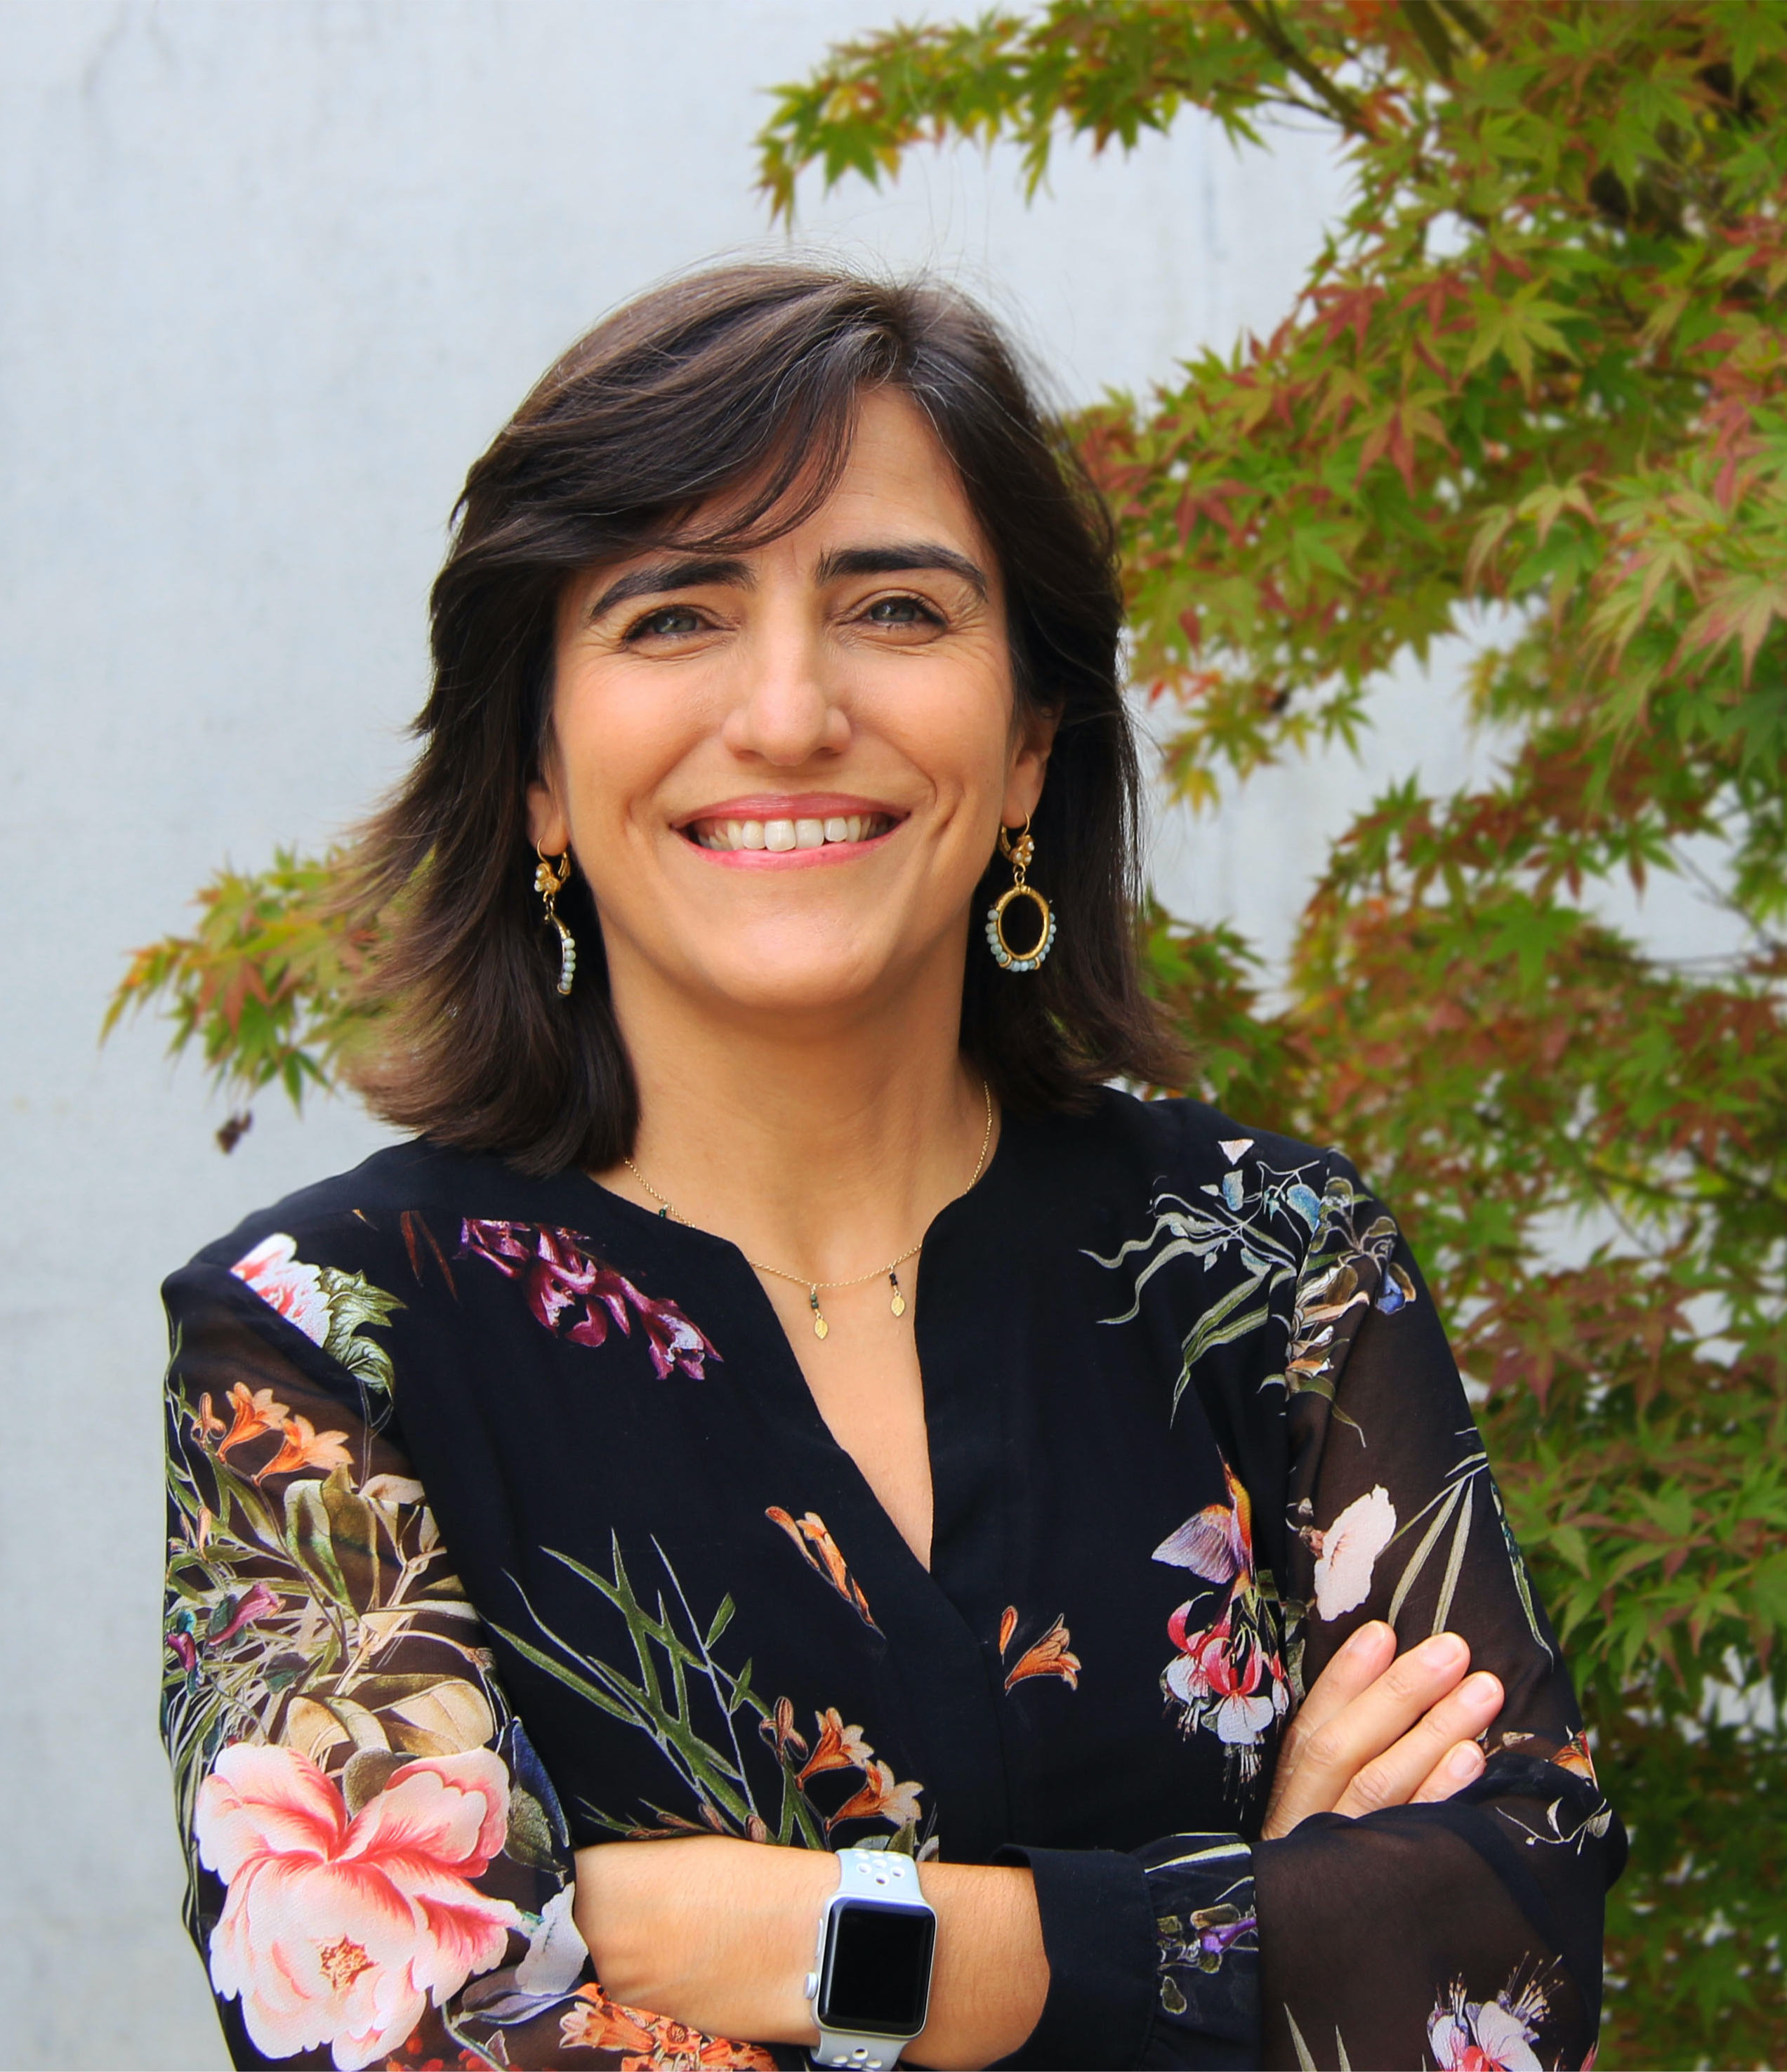

*Ana Paula Pêgo, President*

*(on behalf of the ESB Council)*